Project Development Phase
Model Performance Test — Salesforce
Date | 19 July 2026
Team ID
Project Name | Book a Doctor — Patient/Doctor CRM Integration (Salesforce)
Maximum Marks

Model Performance Testing
Salesforce is used as the back-office CRM for hospital staff, mirroring key records from the MERN application (Patients, Doctors, Appointments) as custom objects so support staff can track follow-ups, complaints, and doctor onboarding outside the patient-facing app.
S.No. | Parameter | Values | Screenshot
1. | Model Summary | Data management setup using custom Objects (Patient, Doctor__c, Appointment__c), Fields (specialty, status, follow-up date) and Reports for staff dashboards. Records sync from the MERN backend via REST API; if data does not match required fields, the record is rejected and an error is logged. | 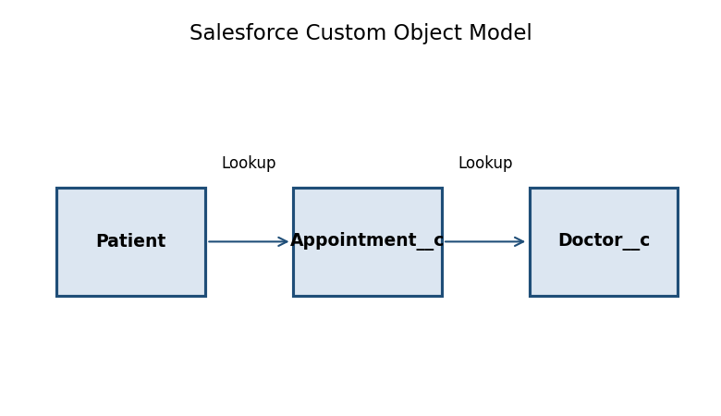
2. | Accuracy | Not Applicable — this is a data/CRM integration, not a trained ML model. | —
3. | Confidence Score (Only for YOLO Projects) | Not Applicable — no object-detection (YOLO) component in this project. | —
Fig. 1 — Salesforce Custom Object Model: Patient → Appointment__c → Doctor__c

